Memento Imago - Narrative Design

Caerwyn Bartley

# Profiles for key aspects of the story

## Story Overview:

**Start Section** *(Linear)*:

A new device called the Visualisation Camera has been developed which allows the projection of previously captured photographs into the same area where they were taken to gain evidence from previously unsolvable crimes. On a dark July winter night in the year 2035, a detective has been tasked with uncovering evidence from a cold murder case that had taken place 2 years prior around the murder of a wealthy family in their own home by using photographs left by their amateur photographer son, and their murderer.

While no evidence was left at the crime scene there were several pieces of evidence has been left within the photograph that had been left at the scene of the crime.

**Evidence Gathering Section** *(Non-Linear)*:

**Creepy Photograph (9:52pm – 26th July 2033):**

A photograph taken by the murderer of the family playing charades, a couple smoked cigarettes have been left on the floor by the murderer. (The cigarettes are a piece of evidence)

**Muddy Footprint Photograph (6:34am – 27th July 2033):**

Photograph of a set of muddy footprints left by the murderer the night previously along with a photograph he had taken of the family the night before (Creepy Photograph).

**Dinner Photograph (7:45am – 27th July 2033):**

A photograph taken by the son of the family sitting around at the dinner table eating their breakfast while the father is talking about a photograph he had found outside the front door of the house in the morning. The daughter and mother are shocked by the news of this. A key is also left on the table that can be used to unlock the son’s bedroom door.

**Mother Murder Photograph (11:12pm – 27th July 2033):**

A photograph of the mother that has been murdered by being strangled by the killer, glasses that the killer had been wearing was broken during the scuffle. There is a photograph of the son’s murder left outside the door of the master bedroom along with a pool of blood. (The glasses are a piece of evidence).

**Son Murder Photograph (10:33pm – 27th July 2033):**

A photograph of the son murdered by having his throat slit and tossed down the stairs. The son was able to take a photograph of the murderer before being killed. A broken camera and the photograph taken by the son is left by the son’s body as well as the father’s murder photograph is left on the entrance table. (The photograph of the murderer taken by the son is a piece of evidence)

**Father Murder Photograph (10:24pm – 27th July 2033):**

A photograph of the father who has been murdered by being stabbed with a fireplace poker by the killer during a scuffle, the father was able to take a tuft of dark brown hair out of the killer’s head before dying. (the hair tuft and fireplace poker are pieces of evidence)

**Shadowy Man Photograph (9:22pm – 27th July 2033):**

A photograph taken by the son of a shadowy man (the murderer) standing outside the kitchen staring into the house at something. A key to the daughter’s bedroom is also left on the kitchen table.

**Daughter Murder Photograph (10:48pm – 27th July 2033):**

A photograph of the daughter who has been murdered by being stabbed several times by the killer. The knife has been left in the corpse and a set of footprints are also left in the daughter’s blood. (The knife and the set of footprints in the blood are pieces of evidence).

**Ending Section** *(Linear)*:

After the detective has found several pieces of evidence, he decides that the best course of action is to leave the crime scene and come to a conclusion about which of a set of suspects is the killer.

## Vertical Slice Plot Visualisation:

Please see attached ‘Memento Imago – Beat Sheet’ excel document

## Character Backgrounds:

### Father

**Name:**

Vincent Shields

**Age:**

59

**Gender:**

Male

**Hair Colour:**

Brown

**Facial Hair:**

Moustache

**Eye Colour:**

Blue

**Height:**

180cm

**Occupation:**

Owner of several successful companies

**Living Situation:**

Living in own home with Wife, Son and Daughter

**Relationships:**

Gwendolyn Shields - Wife

Colten Shields - Son

Skylar Shields - Daughter

**Personality Profile:**

* Protective of family (Willing to put life on the line to protect them)
* Loves his family

### Mother

**Name:**

Gwendolyn Shields

**Age:**

55

**Gender:**

Female

**Hair Colour:**

Brown

**Eye Colour:**

Brown

**Height:**

167cm

**Occupation:**

In partnership with Husband in ownership of several software companies

**Living Situation:**

Living in own home with Husband, Son and Daughter

**Relationships:**

Vincent Shields - Husband

Colten Shields - Son

Skylar Shields - Daughter

**Personality Profile:**

* Loves family
* Heavy Sleeper

### Son

**Name:**

Colten Shields

**Age:**

22

**Gender:**

Male

**Hair Colour:**

Brown

**Facial Hair**:

None

**Eye Colour:**

Brown

**Height:**

175rcm

**Occupation:**

Student/Unemployed

**Living Situation:**

Living with parents

**Relationships:**

Vincent Shields – Father

Gwendolyn Shields – Mother

Skylar Shields - Sister

**Personality Profile:**

* Amateur photographer
* Takes photographs of everything, including his family

### Daughter

**Name:**

Skylar Shields

**Age:**

20

**Gender:**

Female

**Hair Colour:**

Brown

**Eye Colour:**

Blue

**Height:**

161cm

**Occupation:**

Student/Unemployed

**Living Situation:**

Living with parents

**Relationships:**

Vincent Shields – Father

Gwendolyn Shields – Mother

Colten Shields - Brother

**Personality Profile:**

* Hard worker
* Sleeps often

### Murderer

**Name:**

Adam Dylans

**Age:**

34

**Gender:**

Male

**Hair Colour:**

Dark Brown

**Eye Colour:**

Brown

**Height:**

182cm

**Occupation:**

Stock Broker (previously a butcher)

**Living Situation:**

Living alone in his own house with 1 pet dog

**Personality Profile:**

* Calm façade
* Insane minded with psychotic tendencies.
* Short sighted
* Avid photographer
* Slightly clumsy but still smart

## Annotated Images of Level:

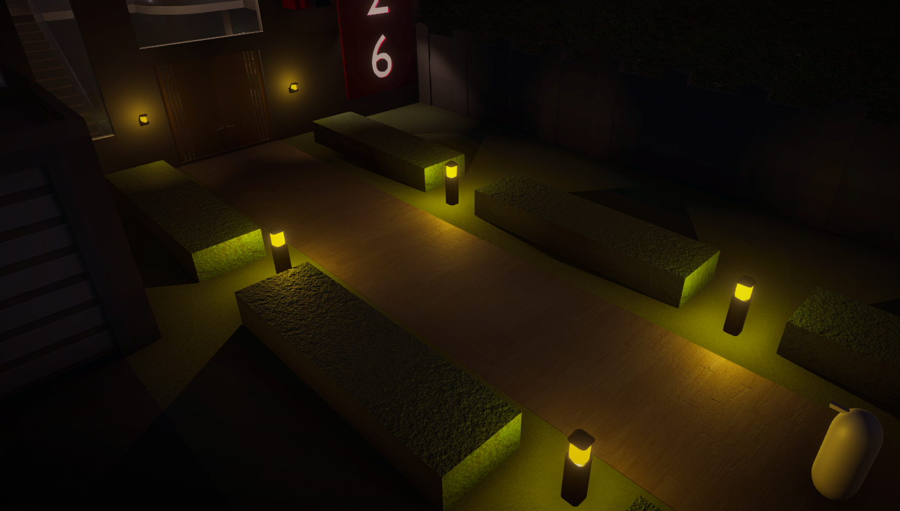

Entrance into house, there are 3 pieces of text that are from the mind of the detective about the crime scene and how they want to catch the murderer.

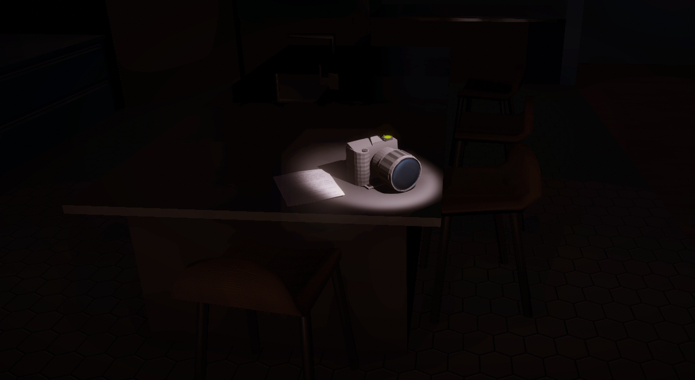

All the lights turn off and the camera is shown as the only lit object in the scene to push the play to pick it up. A note is also left that provides information about how to use the camera

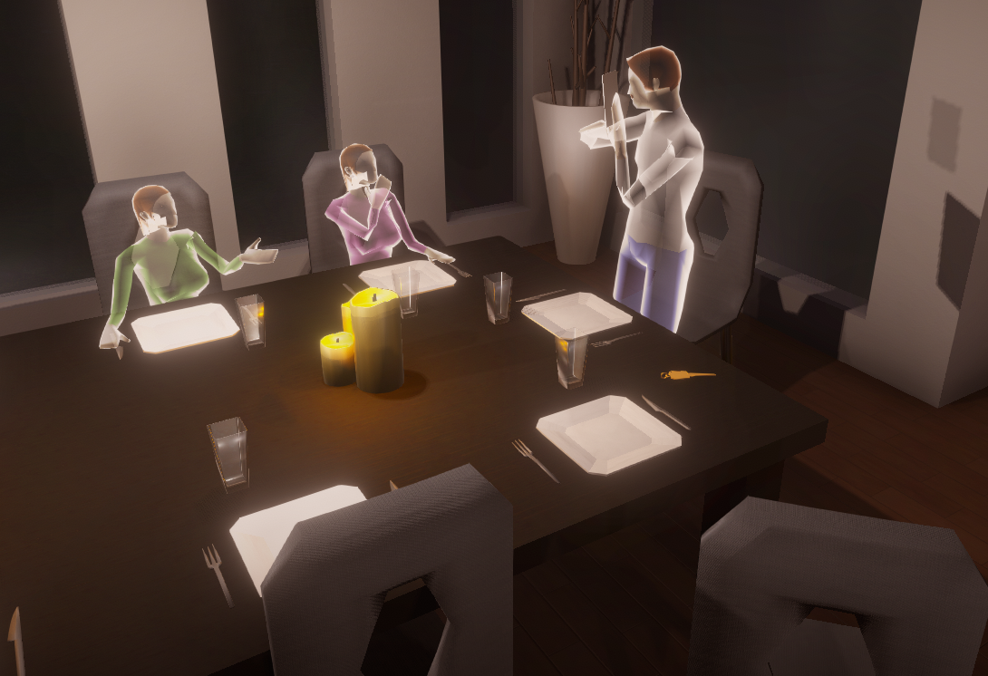

Once the player has picked up the camera and used the first photograph with the camera a scene of the family discussing a photograph is appeared to the player, A key to the son’s bedroom is also left on the table.

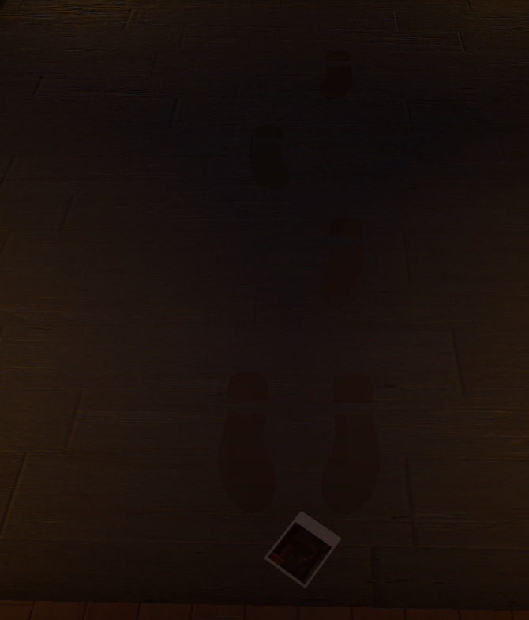

Once the player has picked up the photograph held by the father and the photograph Is used in the camera at the entrance door, a set of footprints leading to the door appear alongside a photograph of the family taken by the murderer.

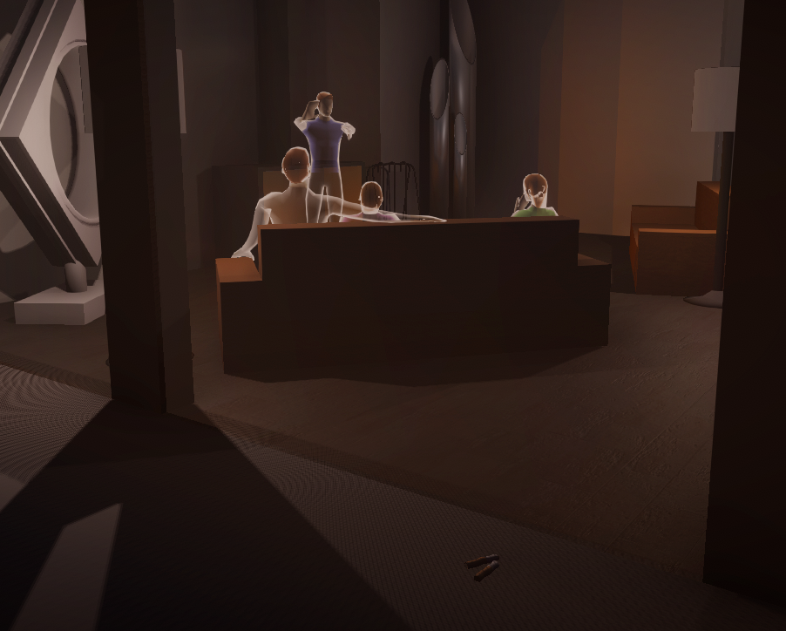

After picking and using the photograph left by the murderer at the front entrance, the player is greeted with a scene of the family playing charades along with a set of smoked cigarette butts laying on the ground outside the house.

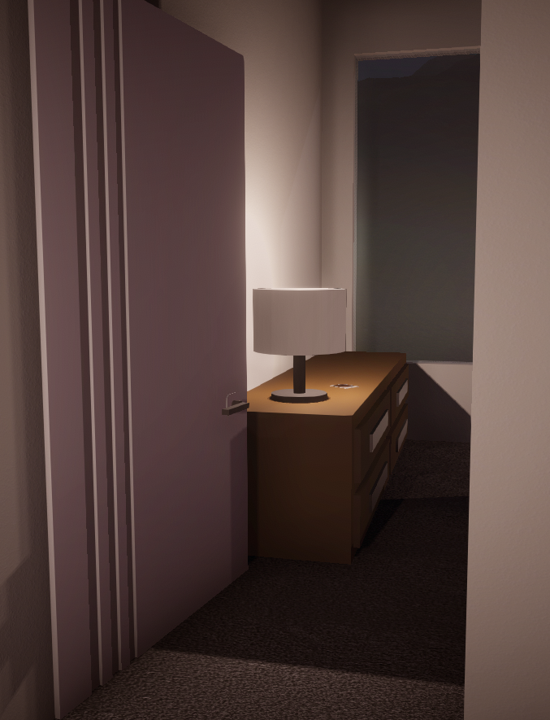

Once the player goes upstairs, they can use the key left on the table in the dining room photograph to unlock the son’s bedroom where there is a photograph left on the son’s dresser of a shadowy man.

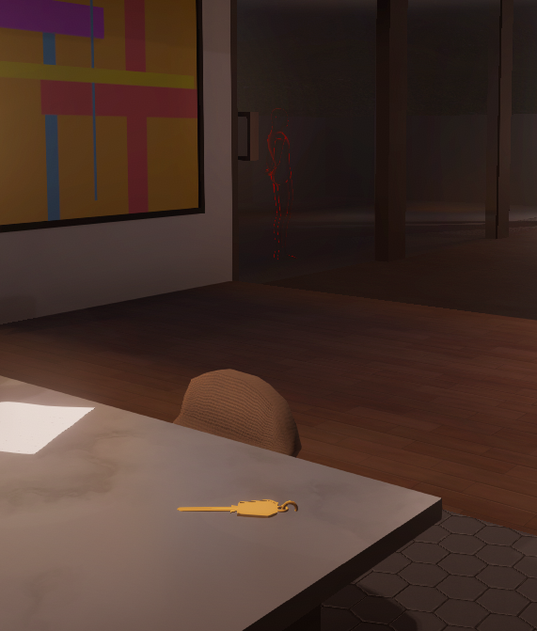

Once the player uses the photograph from the son’s bedroom a key to the daughter’s bedroom door appears on the kitchen table as well as a shadowy man standing outside the door to the backyard staring at something.

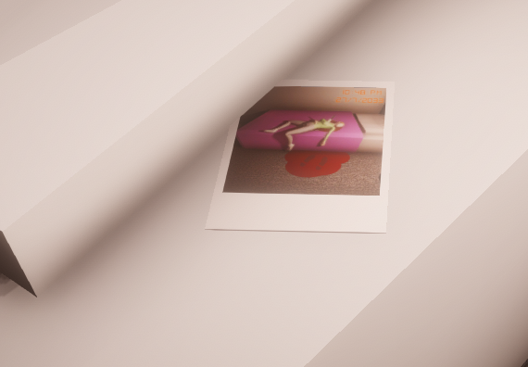

Once the player goes back upstairs and unlocks the daughter’s bedroom door there is a photograph of her murder left under her pillow

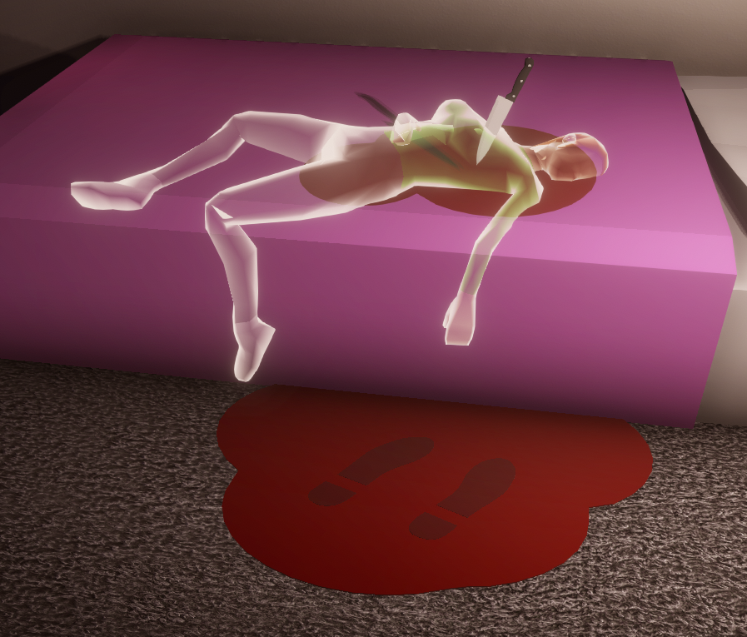

When the player uses the daughter’s murder photograph the scene of her murder appears to the player where she appears to be stabbed and a pool of blood has been left on the carpet with a set of footprints in the blood.

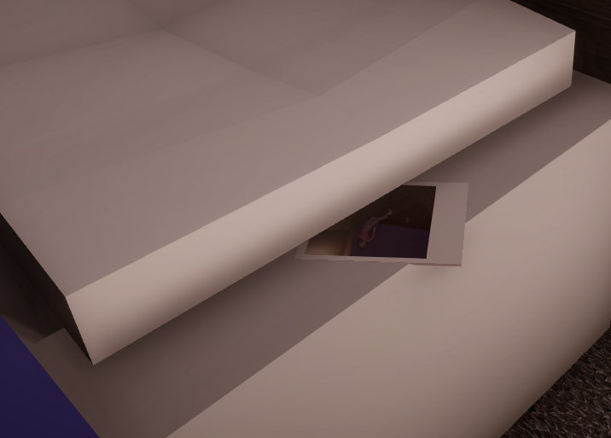

When the player enters into the master bedroom there is a photograph of the mother’s murder laid out under one of the pillows.

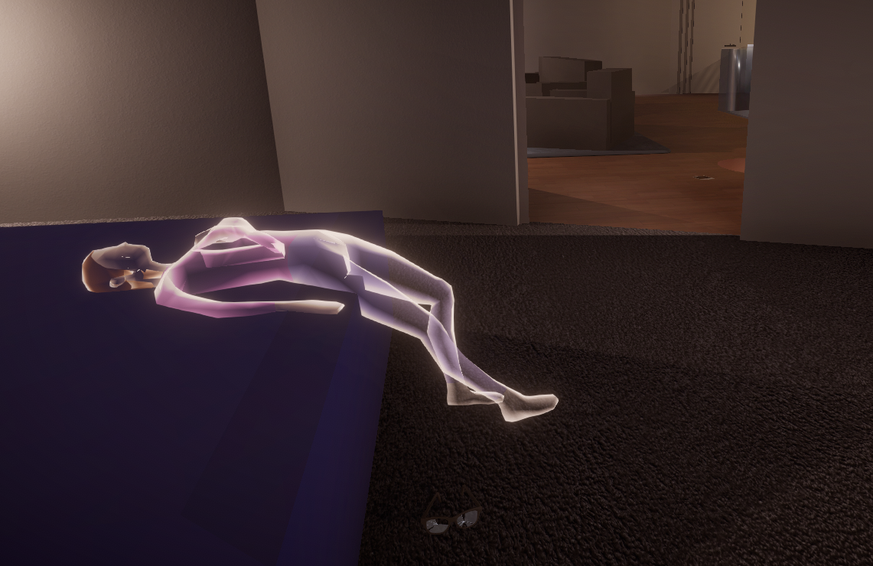

Once the player uses the mothers murder photograph with the camera, a scene of the mother who has been strangled appears before them. Broken glasses lay on the ground as well as a pool of blood (cut off as the rest of the pool was not part of the photograph) and the son’s murder photograph is laying outside of the master bedroom.

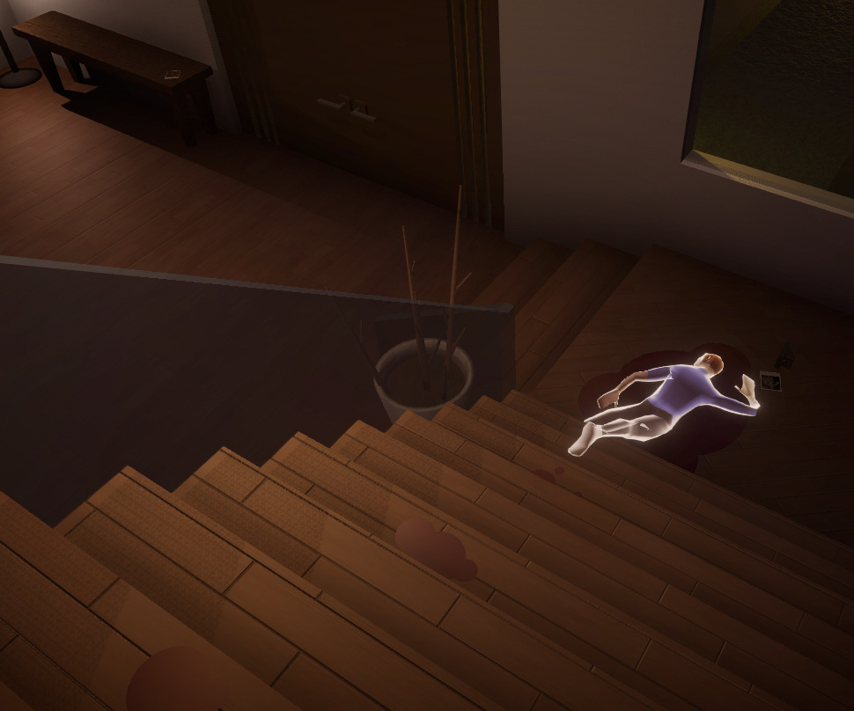

Once the player uses the son’s murder photograph on the staircase a scene of the son, who has been murdered by having his throat slit and tossed down the stairs, appears. Pools of blood are on the stairs along with a broken photograph, blurry photograph of the murderer taken by the son moments before his death are lying next to the son’s corpse, the fathers murder photograph is also on the entrance table.

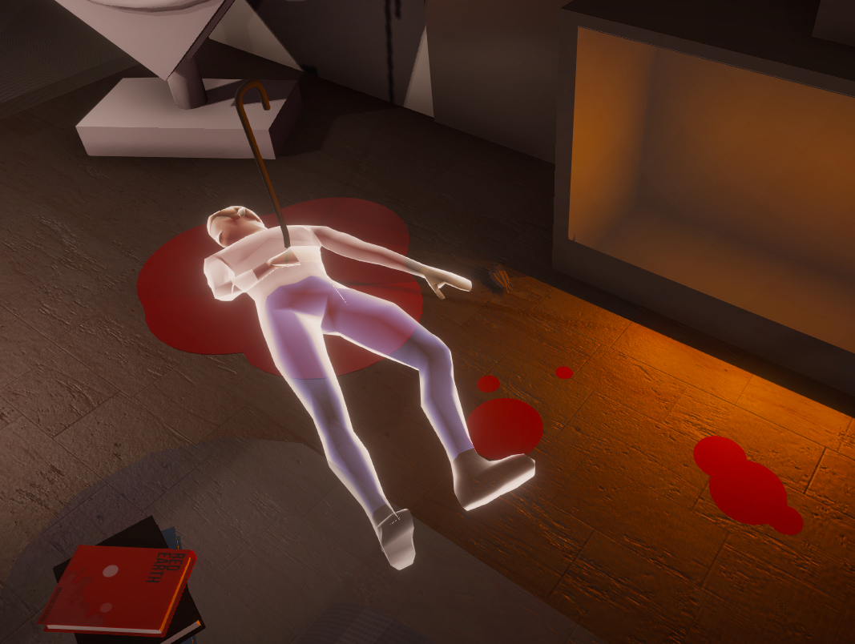

Once the player uses the fathers murder photograph a scene of the father, who has been stabbed by a fireplace poker, appears to the player. Pools of blood surround the father’s corpse as well as a tuft of dark brown hair that was ripped out of the murderers head during a scuffle is lying next to the fathers hand.

# Narrative Planning

## How the games mechanics, gameplay and level design connect with (or serve) the narrative:

### Mechanics:

**Visualisation Camera:**

* Progresses the narrative by visually displaying crime scenes after photographs are placed into the camera and used in the level.

**Object Interaction:**

* Allows the player to pick up and interact with objects in the scene to gain evidence thus progressing the narrative in the search of the correct suspect and what the events of the murder.

**Suspect Detection:**

* Allows the player to piece together the narrative and slowly figure out which one of the several suspects is the murderer.

### Gameplay:

* Using the above mechanics, the player takes the role of a detective at the crime scene (the family house) where the murders occurred and uncovers what happened and who of the set of suspects is the murderer by discovering and inspecting evidence and clues through the photograph projections.

### Level Design:

* Several open spaces to allow ample room to serve for crime scene areas
* Large ceilings, several art pieces, large open empty spaces and a modernist/minimalist design of the house accentuates how the house is owned by a wealthy family
* Several small detail objects such as books, art pieces, knives and forks, etc, emphasise how the house is/was lived in by a family.